Profinet通讯使用说明（样例）

1. 工具软件

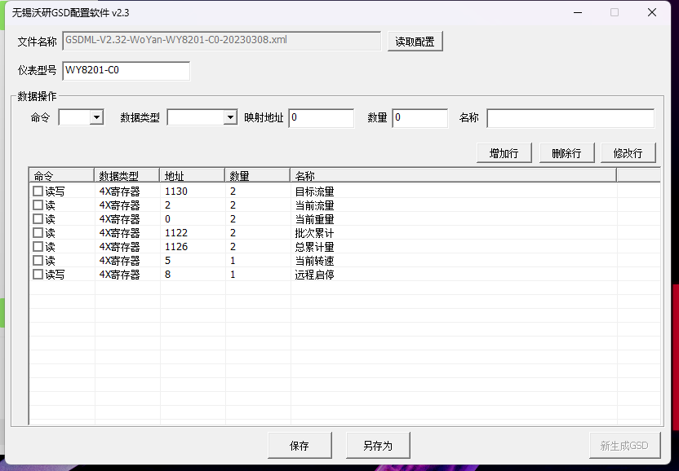

1. **注意事项**

2.1、GSD文件总行数应小于16行

2.1、系统内部自带2项内容，1、IO输入输出，2指令数据交换

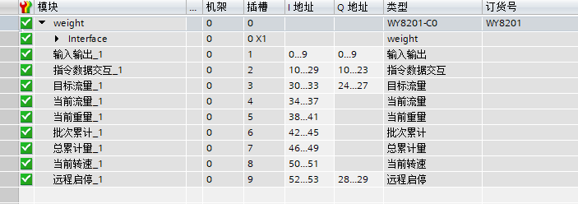

1. **指令数据交互说明:**

**3.1：字节定义(以上图自动分配地址为例)**

|  |  |  |  |  |  |  |  |  |
| --- | --- | --- | --- | --- | --- | --- | --- | --- |
| QW10 | QW12 | QW14 | QW16 | QW18 | QW20 | QW22 |  |  |
| 写类型 | 写地址 | 写高字 | 写低字 | 读类型 | 读地址 | 读内容 |  |  |

|  |  |  |  |  |  |  |  |  |
| --- | --- | --- | --- | --- | --- | --- | --- | --- |
| IW10 | IW12 | IW14 | IW16 | IW18 | IW20 | IW22 | IW24 | ID28 |
| 写类型 | 写地址 | 写高字 | 写低字 | 读类型 | 读地址 | 读高字 | 读低字 | 当前重量 |

读写类型：0禁用，1单字，2双字，3字位，4线圈

读写指令可以同时用一段QW区同时实现

**3.2：读单字指令示例：读4x0100地址 /代表保留 *代表写命令使用**

|  |  |  |  |  |  |  |  |  |
| --- | --- | --- | --- | --- | --- | --- | --- | --- |
| QW10 | QW12 | QW14 | QW16 | QW18 | QW20 | QW22 |  |  |
| * | * | * | * | 1 | 100 | / |  |  |

交互成功后IW状态

|  |  |  |  |  |  |  |  |  |
| --- | --- | --- | --- | --- | --- | --- | --- | --- |
| IW10 | IW12 | IW14 | IW16 | IW18 | IW20 | IW22 | IW24 | ID28 |
| * | * | * | * | 1 | 100 | / | 内容值 | 当前重量 |

**3.3：读双字指令示例：读4x0200地址 /代表保留 *代表写命令使用**

|  |  |  |  |  |  |  |  |  |
| --- | --- | --- | --- | --- | --- | --- | --- | --- |
| QW10 | QW12 | QW14 | QW16 | QW18 | QW20 | QW22 |  |  |
| * | * | * | * | 2 | 200 | / |  |  |

交互成功后IW状态

|  |  |  |  |  |  |  |  |  |
| --- | --- | --- | --- | --- | --- | --- | --- | --- |
| IW10 | IW12 | IW14 | IW16 | IW18 | IW20 | IW22 | IW24 | ID28 |
| * | * | * | * | 2 | 200 | 高字 | 低字 | 当前重量 |

**3.4：读字位指令示例：读4x0300地址第5位状态 /代表保留 *代表写命令使用**

|  |  |  |  |  |  |  |  |  |
| --- | --- | --- | --- | --- | --- | --- | --- | --- |
| QW10 | QW12 | QW14 | QW16 | QW18 | QW20 | QW22 |  |  |
| * | * | * | * | 3 | 300 | 5 |  |  |

交互成功后IW状态

|  |  |  |  |  |  |  |  |  |
| --- | --- | --- | --- | --- | --- | --- | --- | --- |
| IW10 | IW12 | IW14 | IW16 | IW18 | IW20 | IW22 | IW24 | ID28 |
| * | * | * | * | 3 | 300 | / | 内容值 | 当前重量 |

**3.5：读线圈指令示例：读0x0400地址状态 /代表保留 *代表写命令使用**

|  |  |  |  |  |  |  |  |  |
| --- | --- | --- | --- | --- | --- | --- | --- | --- |
| QW10 | QW12 | QW14 | QW16 | QW18 | QW20 | QW22 |  |  |
| * | * | * | * | 4 | 400 | / |  |  |

交互后IW状态

|  |  |  |  |  |  |  |  |  |
| --- | --- | --- | --- | --- | --- | --- | --- | --- |
| IW10 | IW12 | IW14 | IW16 | IW18 | IW20 | IW22 | IW24 | ID28 |
| * | * | * | * | 4 | 400 | / | 内容值 | 当前重量 |

**3.6：写单字指令示例：读4x0100地址 值50 /代表保留 –代表读使用**

|  |  |  |  |  |  |  |  |  |
| --- | --- | --- | --- | --- | --- | --- | --- | --- |
| QW10 | QW12 | QW14 | QW16 | QW18 | QW20 | QW22 |  |  |
| 1 | 100 | / | 50 | - | - | - |  |  |

交互成功后IW状态

|  |  |  |  |  |  |  |  |  |
| --- | --- | --- | --- | --- | --- | --- | --- | --- |
| IW10 | IW12 | IW14 | IW16 | IW18 | IW20 | IW22 | IW24 | ID28 |
| 1 | 100 | / | 50 | - | - | - | - | 当前重量 |

**3.7：写双字指令示例：读4x0200地址 值1234567 /代表保留 –代表读使用**

|  |  |  |  |  |  |  |  |  |
| --- | --- | --- | --- | --- | --- | --- | --- | --- |
| QW10 | QW12 | QW14 | QW16 | QW18 | QW20 | QW22 |  |  |
| 2 | 200 | 18 | 54919 | - | - | - |  |  |

交互成功后IW状态：

|  |  |  |  |  |  |  |  |  |
| --- | --- | --- | --- | --- | --- | --- | --- | --- |
| IW10 | IW12 | IW14 | IW16 | IW18 | IW20 | IW22 | IW24 | ID28 |
| 2 | 200 | 18 | 54919 | - | - | - | - | 当前重量 |

**3:8：写字位指令示例：写4x0300地址第5位状态1 /代表保留 –代表读使用**

|  |  |  |  |  |  |  |  |  |
| --- | --- | --- | --- | --- | --- | --- | --- | --- |
| QW10 | QW12 | QW14 | QW16 | QW18 | QW20 | QW22 |  |  |
| 3 | 300 | 5 | 1 | - | - | - |  |  |

交互成功后IW状态

|  |  |  |  |  |  |  |  |  |
| --- | --- | --- | --- | --- | --- | --- | --- | --- |
| IW10 | IW12 | IW14 | IW16 | IW18 | IW20 | IW22 | IW24 | ID28 |
| 3 | 300 | 5 | 1 | - | - | - | - | 当前重量 |

**3.9：读线圈指令示例：写0x0500地址状态1 /代表保留 –代表读使用**

|  |  |  |  |  |  |  |  |  |
| --- | --- | --- | --- | --- | --- | --- | --- | --- |
| QW10 | QW12 | QW14 | QW16 | QW18 | QW20 | QW22 |  |  |
| 4 | 500 | / | 1 | - | - | - |  |  |

交互成功后IW状态

|  |  |  |  |  |  |  |  |  |
| --- | --- | --- | --- | --- | --- | --- | --- | --- |
| IW10 | IW12 | IW14 | IW16 | IW18 | IW20 | IW22 | IW24 | ID28 |
| 4 | 500 | / | 1 | - | - | - | - | 当前重量 |